**CONFPLUS**

**Spring 2023 CMPS350**

**Web development Fundamentals**

**Project Phase 1**

**Students Name:**

**Osama Osman 201909415**

**Athman Alibrahim 201808162**

**Omar Shalaby 201902693**

**Instructor: DR.Mahmoud Barhamgi**

**CMPS 350 Project Phase 1 – WebApp UI Design and Implementation**

**Conference Management System (ConfPlus)**

**(20% of the course grade)**

|  |  |
| --- | --- |
| **Group Members:** | **Osama Osman 201909415 – OO1909415@QU.EDU.QA**  **Athman Alibrahim 201808162 – AA1808162@QU.EDU.QA**  **Omar Shalaby – OS1902693@QU.EDU.QA** |

|  |  |  |  |  |
| --- | --- | --- | --- | --- |
| **Criteria** | **%** | **Functionality\*** | **Quality of the implementation** | **Your Grade** |
| **Application Design:** Entities, Repositories and Web API class diagrams, flow diagrams | 10% | Working 100% |  |  |
| **Complete and correct implementation of the requirements:** | **80%** | Working 100% |  |  |
| * Login | 10 | Working 100% |  |  |
| * Submit paper | 20 | Working 100% |  |  |
| * Review paper | 20 | Working 100% |  |  |
| * Create/update conference schedule | 20 | Working 100% |  |  |
| * Get conference schedule | 10 | Working 100% |  |  |
| **Testing, documentation, and group work:**   * Use screen shots to illustrate your tests. * For every team member detail, the list of accomplished tasks by the member, **and** the overall contribution percentage to the project (%). * Team coordination: describe in a concise way how the team members collaborated to achieve the project. List the collaboration tools that you have used, if any   **All of these elements should be reported in the template below** | 10% | Working 100% |  |  |
| **Total** | 100 | Working 100% |  |  |

# Current status of the project implementation

All tasks completed – Working 100%

# Application Design

# Sketch

Sketch Link: [https://excalidraw.com/#json=8luS6AJJZR-64dD4C4Yiv,b17Igdg5O3lH_uH3rPdo9w](https://excalidraw.com/%23json=8luS6AJJZR-64dD4C4Yiv,b17Igdg5O3lH_uH3rPdo9w)

Diagram

Main

Sketch Design

# Figma Design

Design Link: <https://www.figma.com/file/YVTa4X2OX0sVMzL4gP8MYO/Conference-Plus-Design?node-id=0%3A1&t=eeXZUrcdc0iFvKAt-1>

Main Page Design

Login

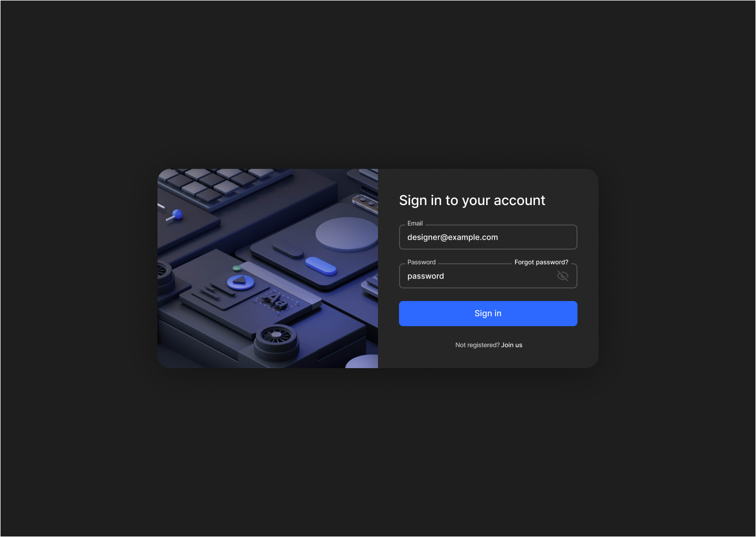

Create Paper

Reviewer

Sessions

Create Session

# Testing

# Login

Login Main Page

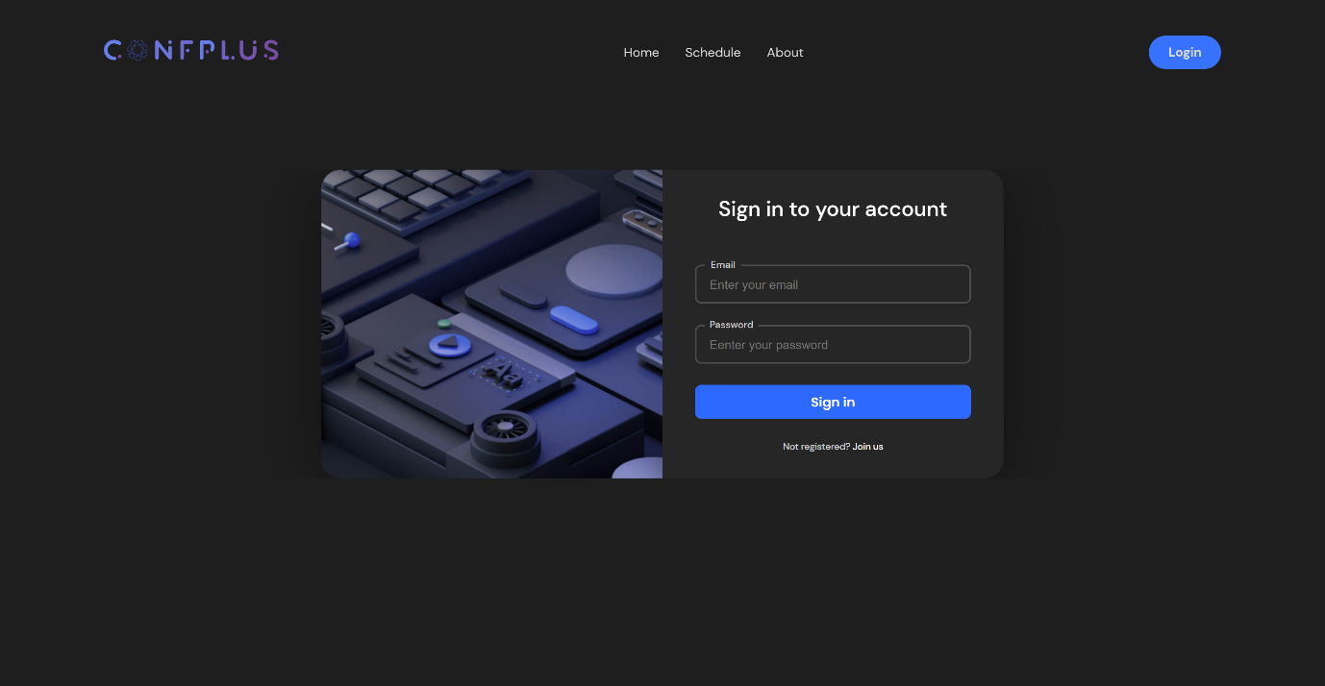

Empty fields

Wrong Email or Password

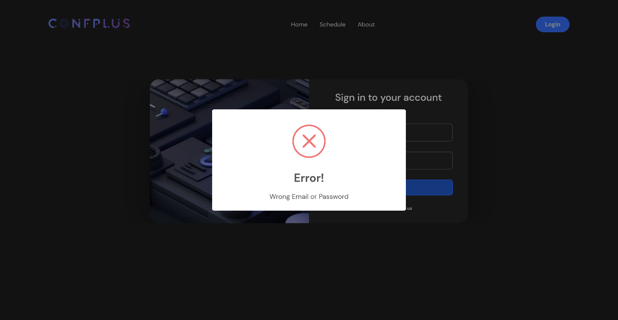

Login and re-direct to the user page

Author Page

Reviewer Page

Organizer Page

# Submit paper.

Author main page

Create Paper

Paper Validation

# Review paper

Review Main Page

Evaluation Paper

Submit Evaluated Paper

# Create/update conference schedule.

Create Session

Submit Session

Session Submission Validation

All Sessions

Update Session

Delete Session

# Get conference schedule.

Schedule

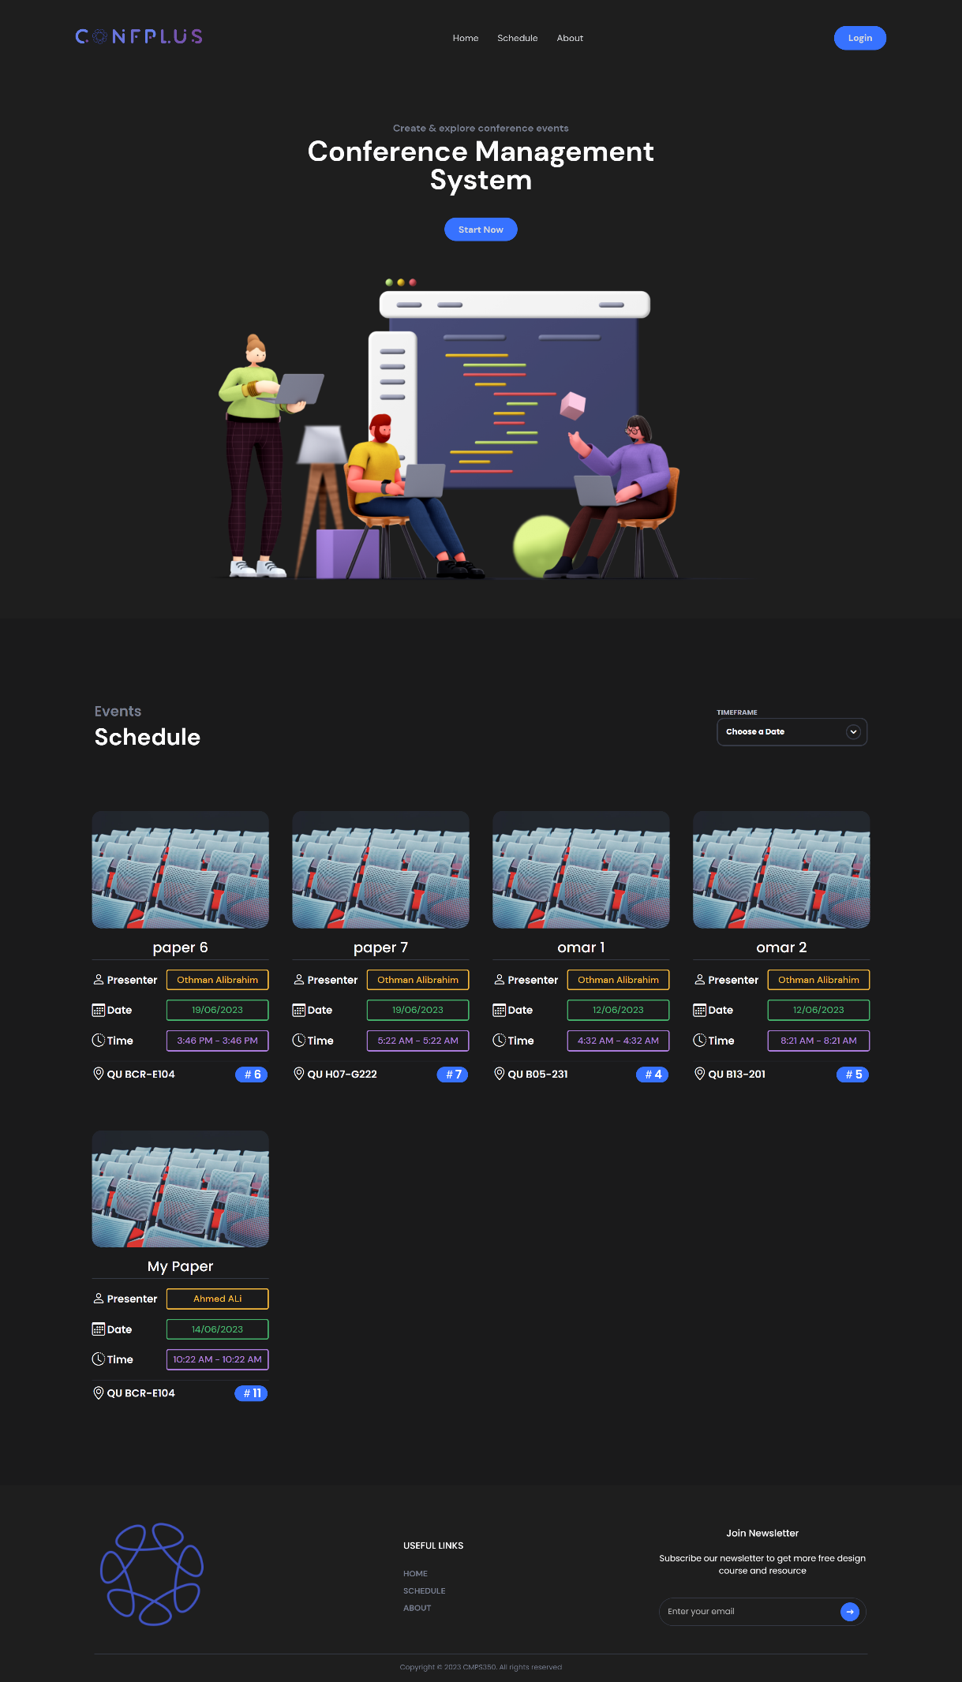

# Discussion of the project contribution of each team member

# Team member contributions

Athman Alibrahim: Organizer JS, HTML+ Reviewer HTML

Omar Shalaby: Reviewer JS, Paper JS + Paper HTML

Osama Osman: Index JS, Login JS + login HTML

# Team coordination

During the course of the project, we held regular meetings to discuss ongoing developments. These meetings took place both in person at the library, as well as online using Microsoft Teams and the Discord app. The virtual meetings provided an opportunity to connect remotely and ensure that progress was being made even when we were unable to meet in person.